FileSync Deletion Requirements

# Competitor Deletion

First, select to delete:

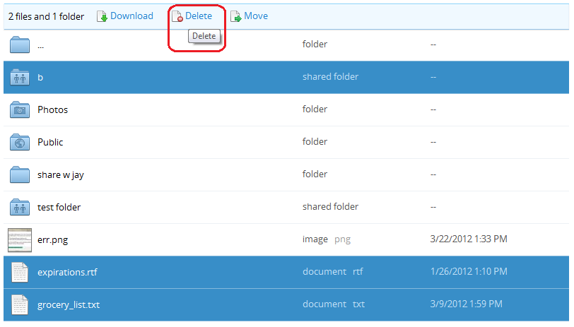

Confirm deletion

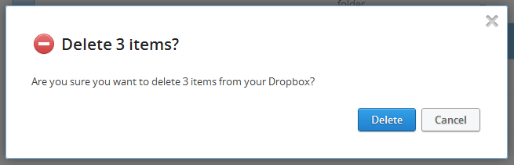

As soon as files are deleted, they cease being listed on the page

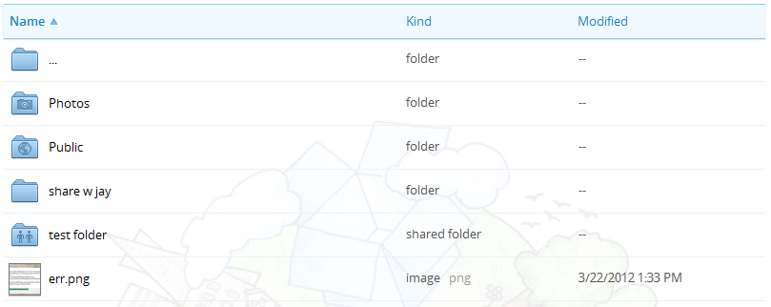

The desktop task-tray app alerts the user that a few files have been deleted.

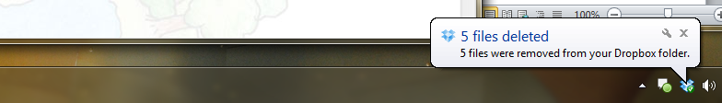

At this point, the files and folders are only soft-deleted. They will still be accessible unless the user permanently deletes them. However, the files do stop consuming account quota the second they are soft-deleted even though they are still technically held on the server. Soft-deleted files will be physically removed 30 days after their deletion date unless they are manually permanently deleted.

Users can see their deleted files by clicking the “Show deleted files” icon:



After I “Show deleted files”, the soft-deleted files show up in a greyed-out style.

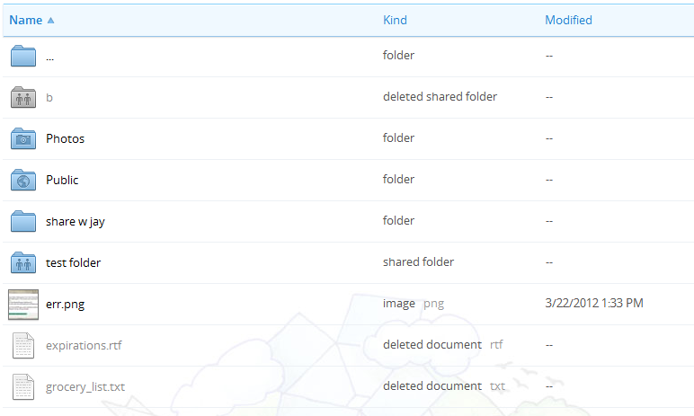

Oops! I accidentally deleted by grocery list! I need it back so I can go shopping. I can accomplish this by highlighting the file and clicking “restore”.

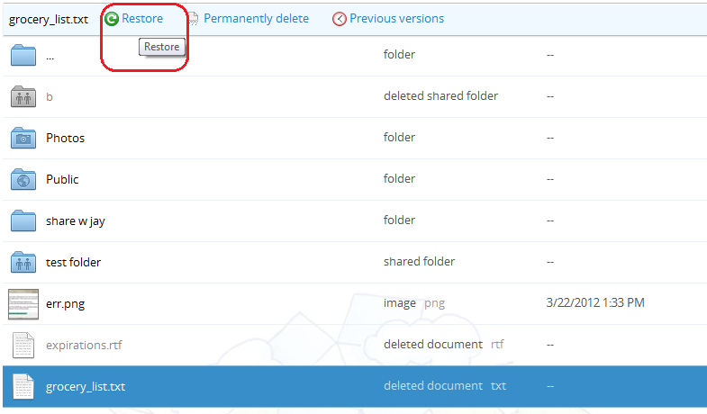

Confirm the restoration

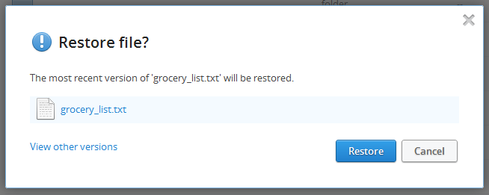

My other file and folder, on the other hand, I did actually mean to delete. They’re taking up space I need, so I will delete the now rather than waiting the 30 days for them to expire.

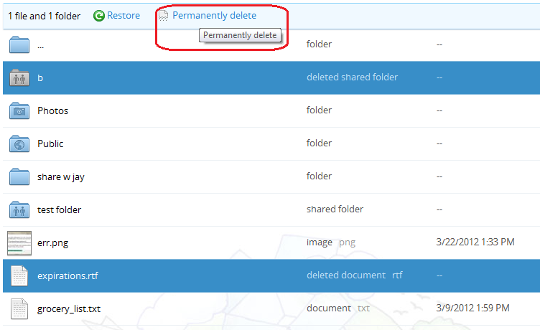

Confirm the deletion

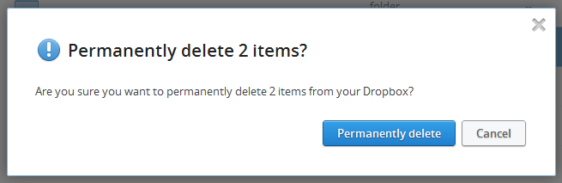

And finally, we are to a point where all files are either fully deleted or fully present. The view when showing deleted files vs. not showing deleted files is now the same:

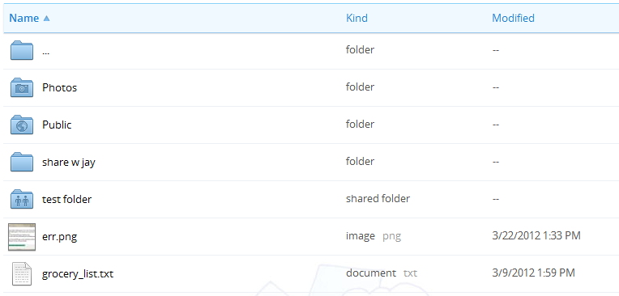

That’s all she wrote for deletion support! To summarize – soft delete leaves files around so that they can be permanently deleted or restore. If no further action is taken, the file with be permanently removed from the server after 30 days.

# SparkWeave Differentiation

1. We will have admin interface options for setting the amount of time after a soft delete to fully expire rather than hard-coding the expiration of old files to 30 days.
   1. If possible, this setting should be overridable per user template.
2. We may discuss whether to deduct files from the user’s quota *before* or *after* a permanent delete.